Java Platform Standard Edition (SE) API specification: https://docs.oracle.com/javase/8/docs/api/

PRACTICAL 1 Applications of ADTs

List Applications

- Your lecturer would like to know the lowest, highest and average of the test scores for this tutorial group. Write a program that would enable your lecturer to do the following using a list:
● Add the test scores obtained by students from your tutorial group. Assume that the test score is a whole number.
● Display all the test scores.
● Find and display the lowest score in the list.
● Find and display the highest score in the list.
● Compute and display the average of the scores in the list.

- For this question, you will use the following Java classes in the Chapter1 NetBeans project’s runningman folder:
- Runner.java
- Registration.java
- RecordResults.java
The Registration class performs registration of marathon runners with the runner number automatically generated. The “Display Runners Info” button will display a pop-up box with the details of the runners who have registered so far (see Figure 1.1).
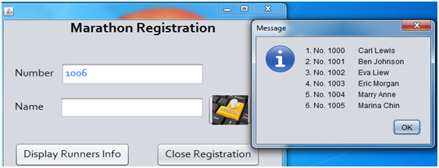
Figure 1.1 Register runner’s name and display runner list

The class RecordResults.java is for recording the runners’ numbers as they cross the finishing line. Complete the following methods for the class RecordResults:
(a) Method jtfNumberActionPerformed()- refer to Figure 1.2(a) for expected output.
(b) Method jtfConfirmActionPerformed()- refer to Figure 1.2(b) for expected output.

Extra challenge
Perform the necessary validation, e.g.:
- To check if a runner number that is entered exists
- A runner should only be recorded as crossing the finishing line at most once
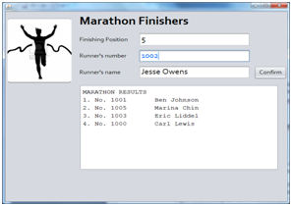 |  | 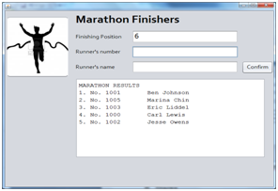
Figure 1.2(a) AfterjtfNumberActionPerformed() runs |  | Figure 1.2(b) After jtfConfirmActionPerformed() runs

Stack Applications
3. Write a method that uses the Stack ADT to evaluate a mathematical expression for proper pairing of brackets, i.e. (), {}, and []. The method returns true if the mathematical expression has balanced pairing of brackets, otherwise returns false.

4. Write a method that uses the Stack ADT to evaluate a postfix expression. Assume that the postfix expression to be processed is in the correct form and each operand consists of a single digit. For example, “(6 + 2) / (5 * 3)” would be entered as “62+53*/” by the user.

Extra challenge
Create an enhanced version of your solution such that your method is able to handle postfix expressions containing operands consisting of more than 1 digit or even real-valued numbers.

Queue Applications
5. A palindrome is a string of characters (a word, phrase or sentence) that is the same regardless of whether you read it forward or backward – assuming that you ignore spaces, punctuation, and case. Examples of palindromes are “Race car” and “A man, a plan, a canal: Panama!”. Write a program that uses both a stack and a queue to determine whether a string is a palindrome or not.

6. For this question, you will use the following Java classes in the Chapter1 NetBeans project’s postoffice folder:
- Customer.java
- PostOfficeSim.java
The class PostOfficeSim.java simulates a post office’s single-queue-multicounter environment whereby customers take a number and when their turn comes, their number and the servicing counter will be announced (refer to Figure 1.3 for the GUI).
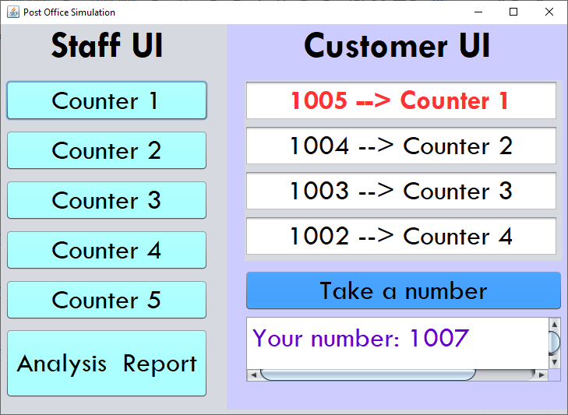
Figure 1.3 GUI for PostOfficeSim

Complete the following methods for the class PostOfficeSim:
- The event handler for the “Take a number” button. The text area below this button should then display “Your number: …” with the automatically generated next sequence number.
- CounterListener’s actionPerformed()method – to be executed when any of the “Counter N” buttons are clicked. Ensure that:
  - The text field in the first row under the Customer UI section will list the next number to be serviced and the assigned counter number.
  - All the remaining text fields below the top row will be updated accordingly.
  - Announce the sequence number to be serviced and the counter number to go to.
- The event handler for the “Print Analysis” button – to be executed when is clicked. Refer to Figure 1.4 for the expected output.
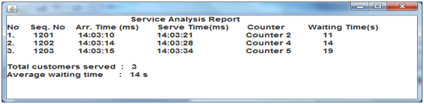
Figure 1.4 The report that will be printed when the “Analysis Report” button is clicked

PRACTICAL 2 Abstract Data Types (ADTs)
- Rational fractions are of the form a / b, where a and b are integers and b ≠ 0.
- Write an ADT specification to represent a fraction. Include operations to set and get the numerator and denominator, as well as to perform arithmetic operations (i.e. addition, subtraction, multiplication and division). For the arithmetic operations, the current fraction is the first operand whilst the second operand is passed as a parameter to the operation and the resulting fraction should be returned.
ADT Fraction
A fraction is a class that can perform calculation between 2 fraction such as add, subtract, multiply and divide.

int getNumerator()
Description : Gets the numerator of current fraction
Postcondition : The fraction remains unchanged
Returns : The value of numerator

int getDenominator()
Description : Gets the denominator of current fraction
Postcondition : The fraction remains unchanged
Returns : The value of denominator

setNumerator()
Description : Sets the value of numerator of current fraction
Postcondition : The value of numerator was changed

boolean setDenominator(int denominator)
Description : Gets the denominator of current fraction
Precondition : The denominator value cannot be 0
Postcondition : The denominator value of current fraction was changed
Returns : True if the denominator has been set successfully, else false

FractionInterface add (FractionInterface fraction2)
Description : Perform addition with another fraction
Postcondition : The current fraction remains unchanged
Returns : The results of addition between 2 fractions

FractionInterface subtract (FractionInterface fraction2)
Description : Perform subtraction with another fraction
Postcondition : The current fraction remains unchanged
Returns : The results of subtraction between 2 fractions

FractionInterface multiply (FractionInterface fraction2)
Description : Perform multiplication with another fraction
Postcondition : The current fraction remains unchanged
Returns : The results of multiplication between 2 fractions

FractionInterface divide (FractionInterface fraction2)
Description : Perform division with another fraction
Precondition : The real value of the fraction passed in cannot be 0
Postcondition : The current fraction remains unchanged
Returns : The results of division between 2 fractions

For parts b and c below, write your code in the Chapter2 NetBeans project’s fraction folder.
- Translate the ADT specification from part (a) into a Java interface.
- Write a class which implements the Java interface from part (b).
Suppose a / b and c / d are rational fractions. Arithmetic operations on fractions are defined by the following rules:
a / b + c / d = (ad + bc) / bd
a / b - c / d = (ad - bc) / bd
a / b x c / d = ac / bd
(a / b) / (c / d) = ad / bc, where c / d ≠ 0
In addition, override the toString() method so that the fraction’s value is returned in the format a / b.
- Test your ADT Fraction implementation using the FractionCalculator class (Figure 3.1 shows the GUI) by completing the relevant sections in the class for this application to be fully functional.
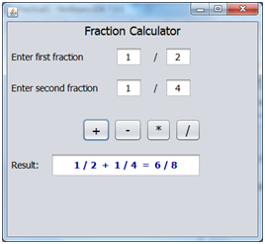
Figure 3.1 GUI for FractionCalculator.java

Extra challenge
Reduce the fraction to the simplest form.

2. Consider an ADT called SquareMatrix which represents a two-dimensional array of integers with n rows and n columns.

- Write the ADT specification and include the following operations (parameters are already listed for the first two operations; for the remaining operations you must determine which parameters to use). State any assumptions made.
- makeEmpty(m), which sets the first m rows and columns to zero.
- storeValue(i, j, value), which stores value into the position at row i, column j. Note that both row and column start from 1.
- add, which adds two matrices together.
- copy, which copies another matrix into this matrix.

ADT Matrix
A matrix is a class that represent different size of matrix and it can perform some operation with another matrix which is also having the same size

boolean storeValue (int row, int col, int value)
Description : Store the value into particular cell of matrix
Precondition : The cell must be existed in the matrix
Postcondition : The value of particular cell in the matrix was changed
Returns : True if the value was stored successfully else false

boolean makeEmpty (int m)
Description : Stored 0 to all the cell in particular row and column
Precondition : The parameter passed in cannot exceed the number of row and column
Postcondition : The value of cell in particular row and column was changed to 0
Returns : True if the value of whole particular row and column change to 0

boolean add (MatrixInterface matrixB)
Description : Perform addition with another matrix
Precondition : The size of the matrix passed in must be same with the size of current
matrix
Postcondition : The current matrix value changed
Returns : True if the addition is successful else false

boolean copy (MatrixInterface matrixB)
Description : Copy the value from another matrix to the current matrix
Precondition : The size of the matrix passed in must be same with the size of current
matrix
Postcondition : The matrix value changed
Returns : True if the operation is successful else false

- Translate the ADT specification from part (a) into a Java interface.

- Create a Java class that implements the interface. Override the toString() method so that the matrix’s value is returned in a n x n layout, for example a 2 x 2 array will appear as:
1 | 2
3 | 4

- Create a simple driver program that tests the ADT.

PRACTICAL 3 Efficiency of Algorithms
- Write a Java program that implements the three algorithms in Chapter 3 (Algorithm A, B and C) and records their average execution time based on 10 iterations for various values of n (e.g., 10, 100. 1000).
The program should display a table of the run times of each algorithm for various values of n.

PRACTICAL 4 Array Implementations of Collection ADTs
- Refer to the adt\ArrayList class within the Chapter4 NetBeans project.
- Would you be able to add any more entries into the list once you have added the DEFAULT_CAPACITY number of entries?
No
- Discuss how you can rectify the problem identified in part a and then implement the solution.
Before the entries are added into the list, checking if the list is full or not, if the list is full, the entries in the list will be stored in a new array first and the list will be resized then only the entries in the new array will be moved to the list.
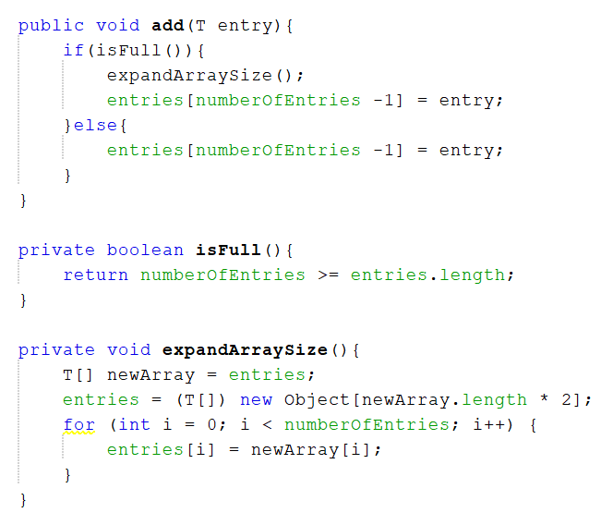

2. A set is a collection of distinct objects. Typical operations on a set include:
- add: Add a new element to the set
- remove: Remove an element from the set
- checkSubset: Check if another set is a subset of the current set
- union: Add another set to the current set
- intersection: Returns a set with elements that are common in both the current set and the given set.
- isEmpty: Check to see if the set is empty

- Write the specification for the Set ADT:
ADT Set
A Set is ………
boolean add(T newElement)
boolean remove(T anElement)
boolean checkSubset(Set anotherSet)
void union(Set anotherSet)
Set intersection(Set anotherSet)
boolean isEmpty()

ADT Set
A set is a collection of distinct objects of type T which only allows different unique elements to be stored. The entry added will be placed on the last position of the set. The set position starts from 0 same to the index.

boolean add (T newElement)
Description : Add a new element into the end of the set
Precondition : The set cannot be full
Postcondition : A new element is added into the set
Returns : True if the element is added successfully else false

boolean remove (T anElement)
Description : Remove an specific element from the set
Precondition : The element must be existed in the set
Postcondition : The specific element was removed in the set
Returns : True if the element was removed successfully else false

boolean checkSubset (Set<T> anotherSet)
Description : Check if another set is actually the subset of the current set
Postcondition : The set remains the same
Returns : True if another set is the subset of current set else false

union (Set<T> anotherSet)
Description : Add another set into the current set
Precondition : The element in another cannot be duplicated with the element in current set.
Postcondition : The elements in another set are added into current set.
Returns : Return true if the elements of another set are added successfully else false.

Set intersection (Set<T> anotherSet)
Description : Find the intersection between the current set and another set.
Postcondition : The set remains the same
Returns : Return the set that contain the elements in the intersection between current set and another set.

boolean isEmpty ()
Description : Check if the set is empty
Postcondition : The set remains the same
Returns : Return true if the set is empty else false

- Implement the Set ADT. Use array-based implementation. You may include any necessary utility methods.

- Write a driver program to test your implementation of the Set ADT.

- Modify the Java interface and class from part b such that your implementation provides an iterator to the set object. Then, include a method in your driver program that uses the iterator to display all the elements in the set object.
Note: You only need to implement the hasNext() and next() methods of the java.util.Iterator interface. Refer to Table 4.1 for a description of the methods.

Table 4.1 java.util.Iterator
public interface Iterator <T> {

/** Task: Detects whether the iterator has completed its traversal
* and gone beyond the last entry in the collection of data.
* @return true if the iterator has another entry to return */
public boolean hasNext();

/** Task: Retrieves the next entry in the collection and
* advances the iterator by one position.
* @return a reference to the next entry in the iteration,
* if one exists
* @throws NoSuchElementException if the iterator had reached the
* end already, that is, if hasNext() is false */
public T next();

/** Task: Removes from the collection of data the last entry that
* next() returned. A subsequent call to next() will behave
* as it would have before the removal.
* Precondition: next() has been called, and remove() has not been
* called since then. The collection has not been altered
* during the iteration except by calls to this method.
* @throws IllegalStateException if next() has not been called, or
* if remove() was called already after the last call to
* next().
* @throws UnsupportedOperationException if this iterator does
* not permit a remove operation. */
public void remove(); // Optional method

} // end Iterator

PRACTICAL 5 Linked Implementations of Collection ADTs
- Implement the ADT stack by using a linked chain with an external reference to its top node. Use the interface StackInterface from Chapter 4.

- Implement the ADT queue by using a circular linked chain with only an external reference to its last node. Only one external reference – to the last node – is maintained, since the first node is found easily from the last one.)

PRACTICAL 6 Recursion

- Write a recursive method countUp that displays the count-up from 1 to n, where n is a positive integer.
Hint: A recursive call will occur before you display anything.

- Write a recursive method that takes two integers and finds the greatest common divisor (GCD).
Complete the Extra Challenge question in Practical 2 Q1 if you have not done so.
Hint: Use Euclid’s Algorithm.

- Write code to compare the performance of 3 different implementations of the Fibonacci numbers: using recursion, iteration and array.

- Write a recursive method displayBackward that writes a given array backward. Consider the last element of the array first.
You may add your code to the Chapter6 NetBeans project’s RecursiveDisplayArray class.

- Write a recursive method countNodes that counts and returns the number of nodes in a chain of linked nodes.
You may add your code to the Chapter6 NetBeans project’s SimpleList class.

PRACTICAL 7 Sorted Lists

- Implement the method remove() in Chapter7\adt\SortedArrayList class.
Note on generic types to enable comparison:
As the entries in this ADT must be in sorted order, the objects in the array must be Comparable. Thus, the class that the generic type T represents must implement the interface Comparable. To ensure this requirement, we write <T extends Comparable<T>>
instead of just <T> after the interface name and the class name. We then can use T as the data type of the parameters and local variables within the methods. Hence, the interface could begin as follows: public interface SortedListInterface<T extends Comparable<T>>
Within the implementation class for the sorted list, we then use the compareTo method to compare an object with the specified object for order.
For the constructor, you need to allocate an array of Comparable objects. Hence, use
new Comparable[aSize] instead of new Object[aSize]

- Consider the class hierarchy in Figure 7.1 which consists of entity classes providing an oversimplified representation of employee levels in a company.
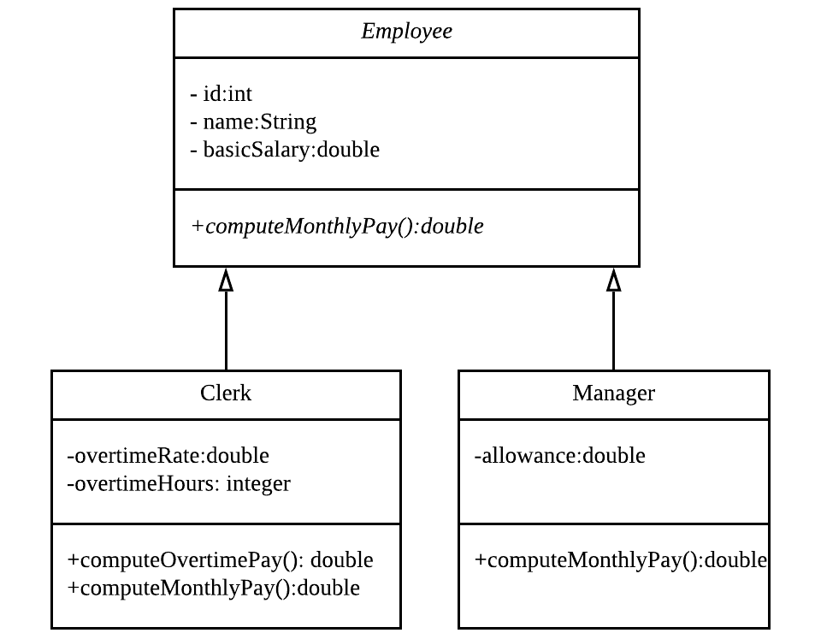
Figure 7.1 Class diagram for employee levels

- Implement the entity classes shown in Figure 7.1 as follows:
  - The Employee class implements the Comparable interface based on id. The Clerk and Manager inherits the compareTo method from the superclass Employee.
  - In each class, include constructors, setters, getters and the method toString.
  - Implement the additional methods in the classes as follows:
    - A clerk’s overtime pay is the overtime hours multiplied by the overtime rate.
    - A clerk’s monthly pay is the basic salary plus overtime pay.
    - A manager’s monthly pay is the basic salary plus allowance
- Write a client program that creates a sorted list of employees with entries comprising manager and clerk objects using the entity classes from part a.
- Implement the method remove() in Chapter7\linked\SortedLinkedList class.

- Sorted linked list with iterator.
- Create a linked implementation of the ADT sorted list which provides an iterator. Define the iterator class as an inner class of the ADT.
- Write a client program that creates a sorted list of employees with entries comprising manager and clerk objects using the entity classes from part a.
- Use the iterator to display the following monthly payroll report:
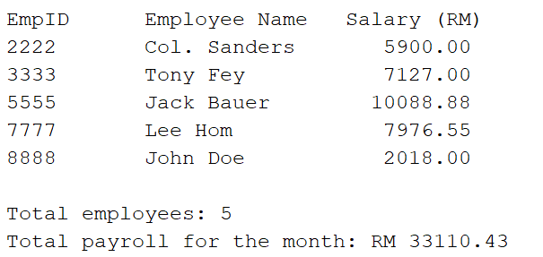

PRACTICAL 8 Algorithms for Searching & Sorting

A. Algorithms for Searching

- When searching a sorted array sequentially, you can ascertain that a given item does not appear in the array without searching the entire array. Modify the method contains in the Chapter8\adt\SortedArrayList class such that it takes advantage of this observation when searching a sorted array sequentially.

- Write a new array implementation of the Chapter8\adt\SortedArrayList class as follows:
- Provide an iterative version of the binary search algorithm that will return the index of the target entry in the array. If the array does not contain the target entry, the method should return the index of the insertion point as a negative value.
- Implement the contains, add and remove methods such that they invoke the binary search method to determine the index of the given entry in the array.
.

B. Algorithms for Sorting

- Implement the iterative selection sort algorithm as a static method in the NetBeans project Chapter8’s SortArray class.

- Implement the iterative insertion sort algorithm (including insertInOrder) as Java methods.

- Implement the recursive selection sort algorithm as a private method using the following method header
private static <T extends Comparable<? super T>>
void selectionSort(T[] a, int first, int last)
and include the following public method to invoke the recursive method:
public static <T extends Comparable<T>>
void selectionSort (T[] a, int n)

PRACTICAL 9 Binary Trees

- Write a program that takes a postfix expression and produces a binary expression tree. You can assume that the postfix expression is a string that has only binary operators and signle-letter operands. After building the expression tree, your program should display the postfix form of the expression.
Hint:
Use a stack of binary subtrees to store the subexpressions. Write your client program in the Chapter9 NetBeans project and use the adt\BinaryTree class to declare and create the stack object as follows:
Stack<BinaryTree<String>> stack = new Stack<>();

- Implement the preorder and postorder traversals of the binary search tree in the Chapter9\adt\BinarySearchTree class.

- Add the following method to the Chapter9\adt\BinarySearchTree class to find and return the smallest entry in the binary search tree:
public T getSmallestValue()
As is often the case with recursive algorithms, implement the actual search as a private method findMinNode() that the public method getSmallestValue() invokes. The private recursive method findMinNode() should find and return the node with the smallest entry in the binary search tree. Use the following method header:
private Node findMinNode(Node node)

Extra challenge

4. A guessing game is a game where the player thinks of something and the program has to guess what it is by asking the player questions that have a yes or no answer. A binary decision tree that grows as the game progresses may be used for this application.
- Given the source code for DecisionTreeInterface.java, create the class(es) for a guessing game. Your game distinguishes between different animals. The user thinks of an animal and the program asks a sequence of questions until it can guess the animal.
For example, Figure 7.1 below shows the initial decision tree and Figure 7.2 shows a possible dialog where the program wins the game. Your program should learn from the user: if the program makes an incorrect guess, it asks the user to enter a new question that can distinguish between the correct animal and the program’s incorrect guess. The decision tree should be updated with this new question. With this new information (i.e. the actual animal in the player’s mind and the new question), we augment the tree:
- we replace the contents of the leaf that contained the wrong answer – “an Elephant” in this case – with the new question provided by the player, and
- we give the leaf 2 children: the left child (the NO answer) is the former leaf (“an Elephant”) and the right child (the YES answer) contains the player’s answer.
Figure 7.3 shows a possible dialog where the program gives an incorrect guess and Figure 4 shows the subsequent augmented tree.

- Add code to store the game decision tree to a binary file and retrieve it for future game sessions.
Hint: You need to ensure that your classes for the node and decision tree implements java.io.Serializable.

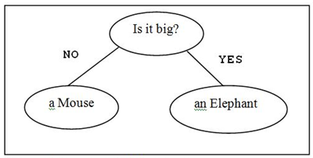 | 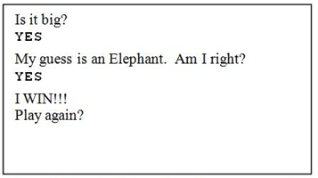
Figure 7.1 Initial decision tree example | Figure 7.2 Sample dialog for correct guess

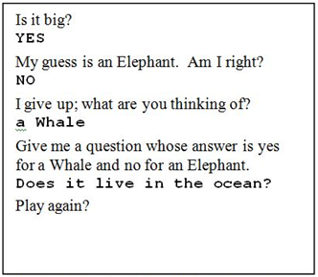 | 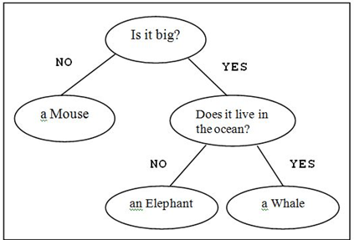
Figure 7.3 Sample dialog for incorrect guess | Figure 7.4

PRACTICAL 10 Hashing

- Recall the various techniques for generating hash codes for a string that was covered in the lecture. Override the hashCode method for the Name class provided in the Chapter10\entity package such that the hash code will produce distinct hash codes for different Name objects.

- Modify the Student class in the Chapter10\entity package such that the id is type long and comprises a 16-digit number. Then, modify the implementation of the method hashCode such that the folding technique is applied as follows:
- break the key into groups of digits
- then combine the groups using addition

- Rewrite the HashedDictionary class such that the collision-resolution scheme used is open addressing with double hashing. Use the following primary and secondary hash functions:
H₁(key) = key % tableSize
H₂(key) = 7 – key % 7

Extra challenge

- Enhance your solution for Practical 1 Question 4 (which is regarding the evaluation of a given postfix expression) such that the operands can be
- consisting of more than 1-digit (e.g. 3.14152)
- Variables (e.g. rate), or
- A mix of alphanumeric tokens, e.g. 5500 rate *

You may assume that a space is used as a delimiter between tokens.
Hint: Use a dictionary to store each variable and its corresponding value.

